Wild Boar <https://pixers.us/wall-murals/sus-scrofa-ferus-25289981>

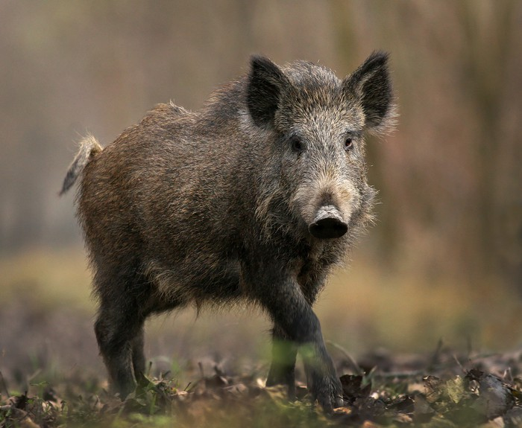

Chester white (domestic pig) <http://www.breedslist.com/chester-white-pig.htm>

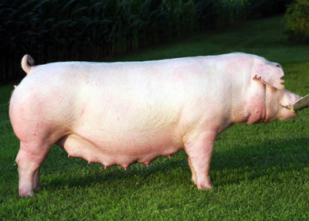

Duroc (domestic pig) <http://www.breedslist.com/duroc-pig.htm#more-701>

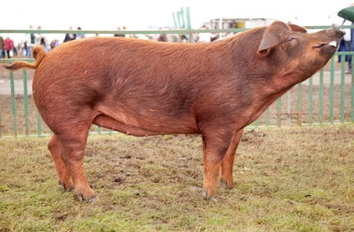

Berkshire (domestic pig) <http://www.nepork.org/breeds-of-swine-berkshire/>

